**Module-6: Assignment-1**

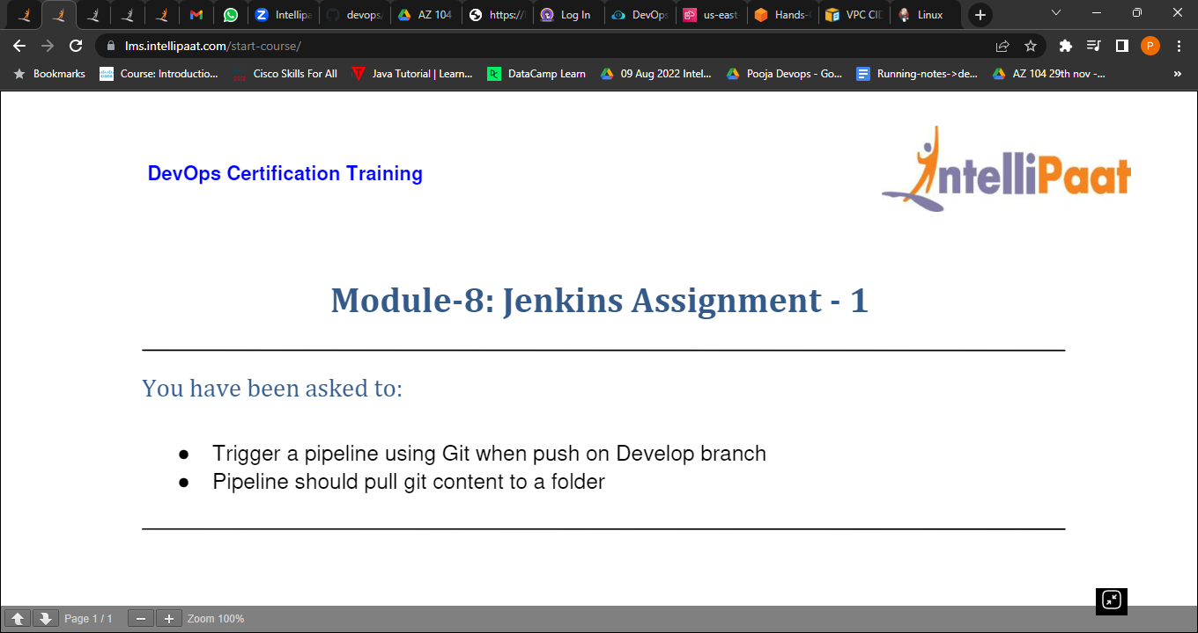

1. Trigger a pipeline using Git when push on a Develop branch.
2. Created a new file in develop branch.
3. Committed the newfile from develop branch
4. Pushed the develop branch to remote repository

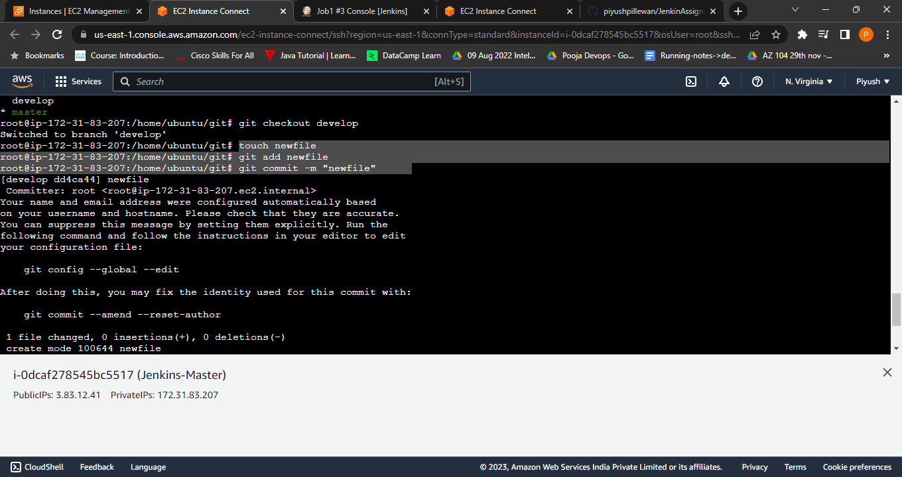

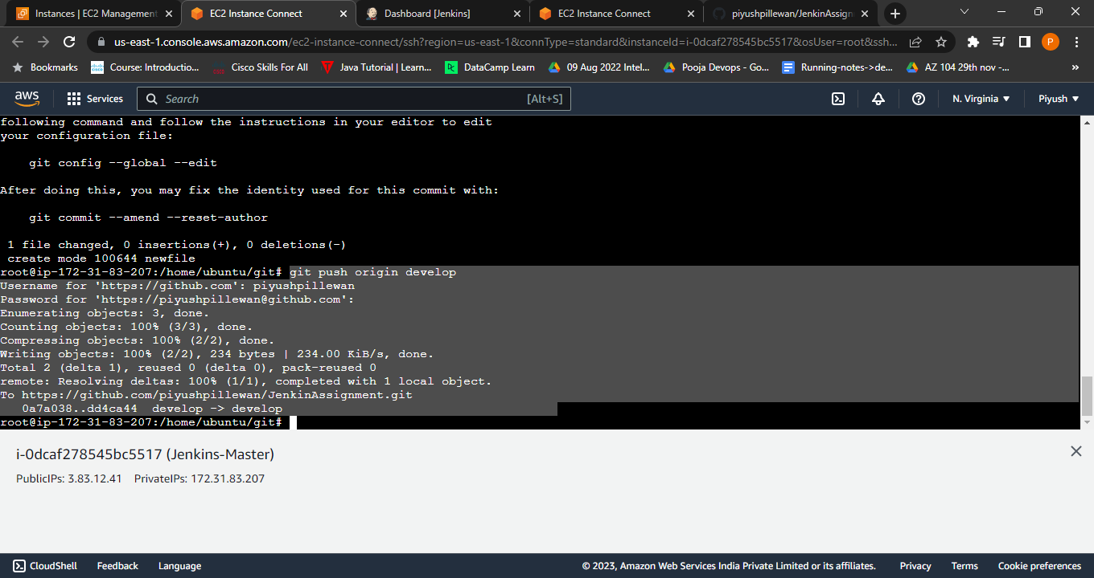

1. Pipeline should pull git content to a folder.
2. Pipeline is triggered using git when pushed to develop branch
3. Build is triggered automatically.
4. Pipeline pulled the git content to a folder



